**PROJECT REPORT**

**GRAPHICS DESIGN USING CANVA**

1. **INTRODUCTION**
   1. Overview

Infographics (a clipped compound of "information" and "graphics") are graphic visual representations of information.

* 1. Purpose

Data, or knowledge intended to present information quickly and clearly.

1. **RESULT**

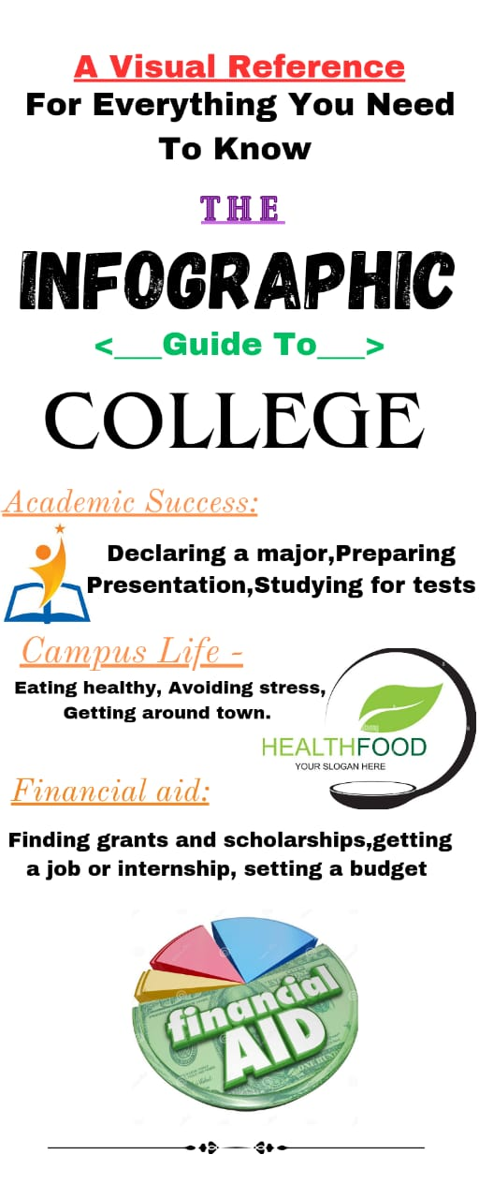

1. **ADVANTAGES & DISADVANTAGES**

i)effective at communicating information, especially on complicated subjects.

ii) high amount of time required for preparation.

1. **APPLICATIONS**

We use th canva application to desing the infigraphcis.

1. **CONCLUSION**

Help the paper feel complete by restating your arguments.

*******************